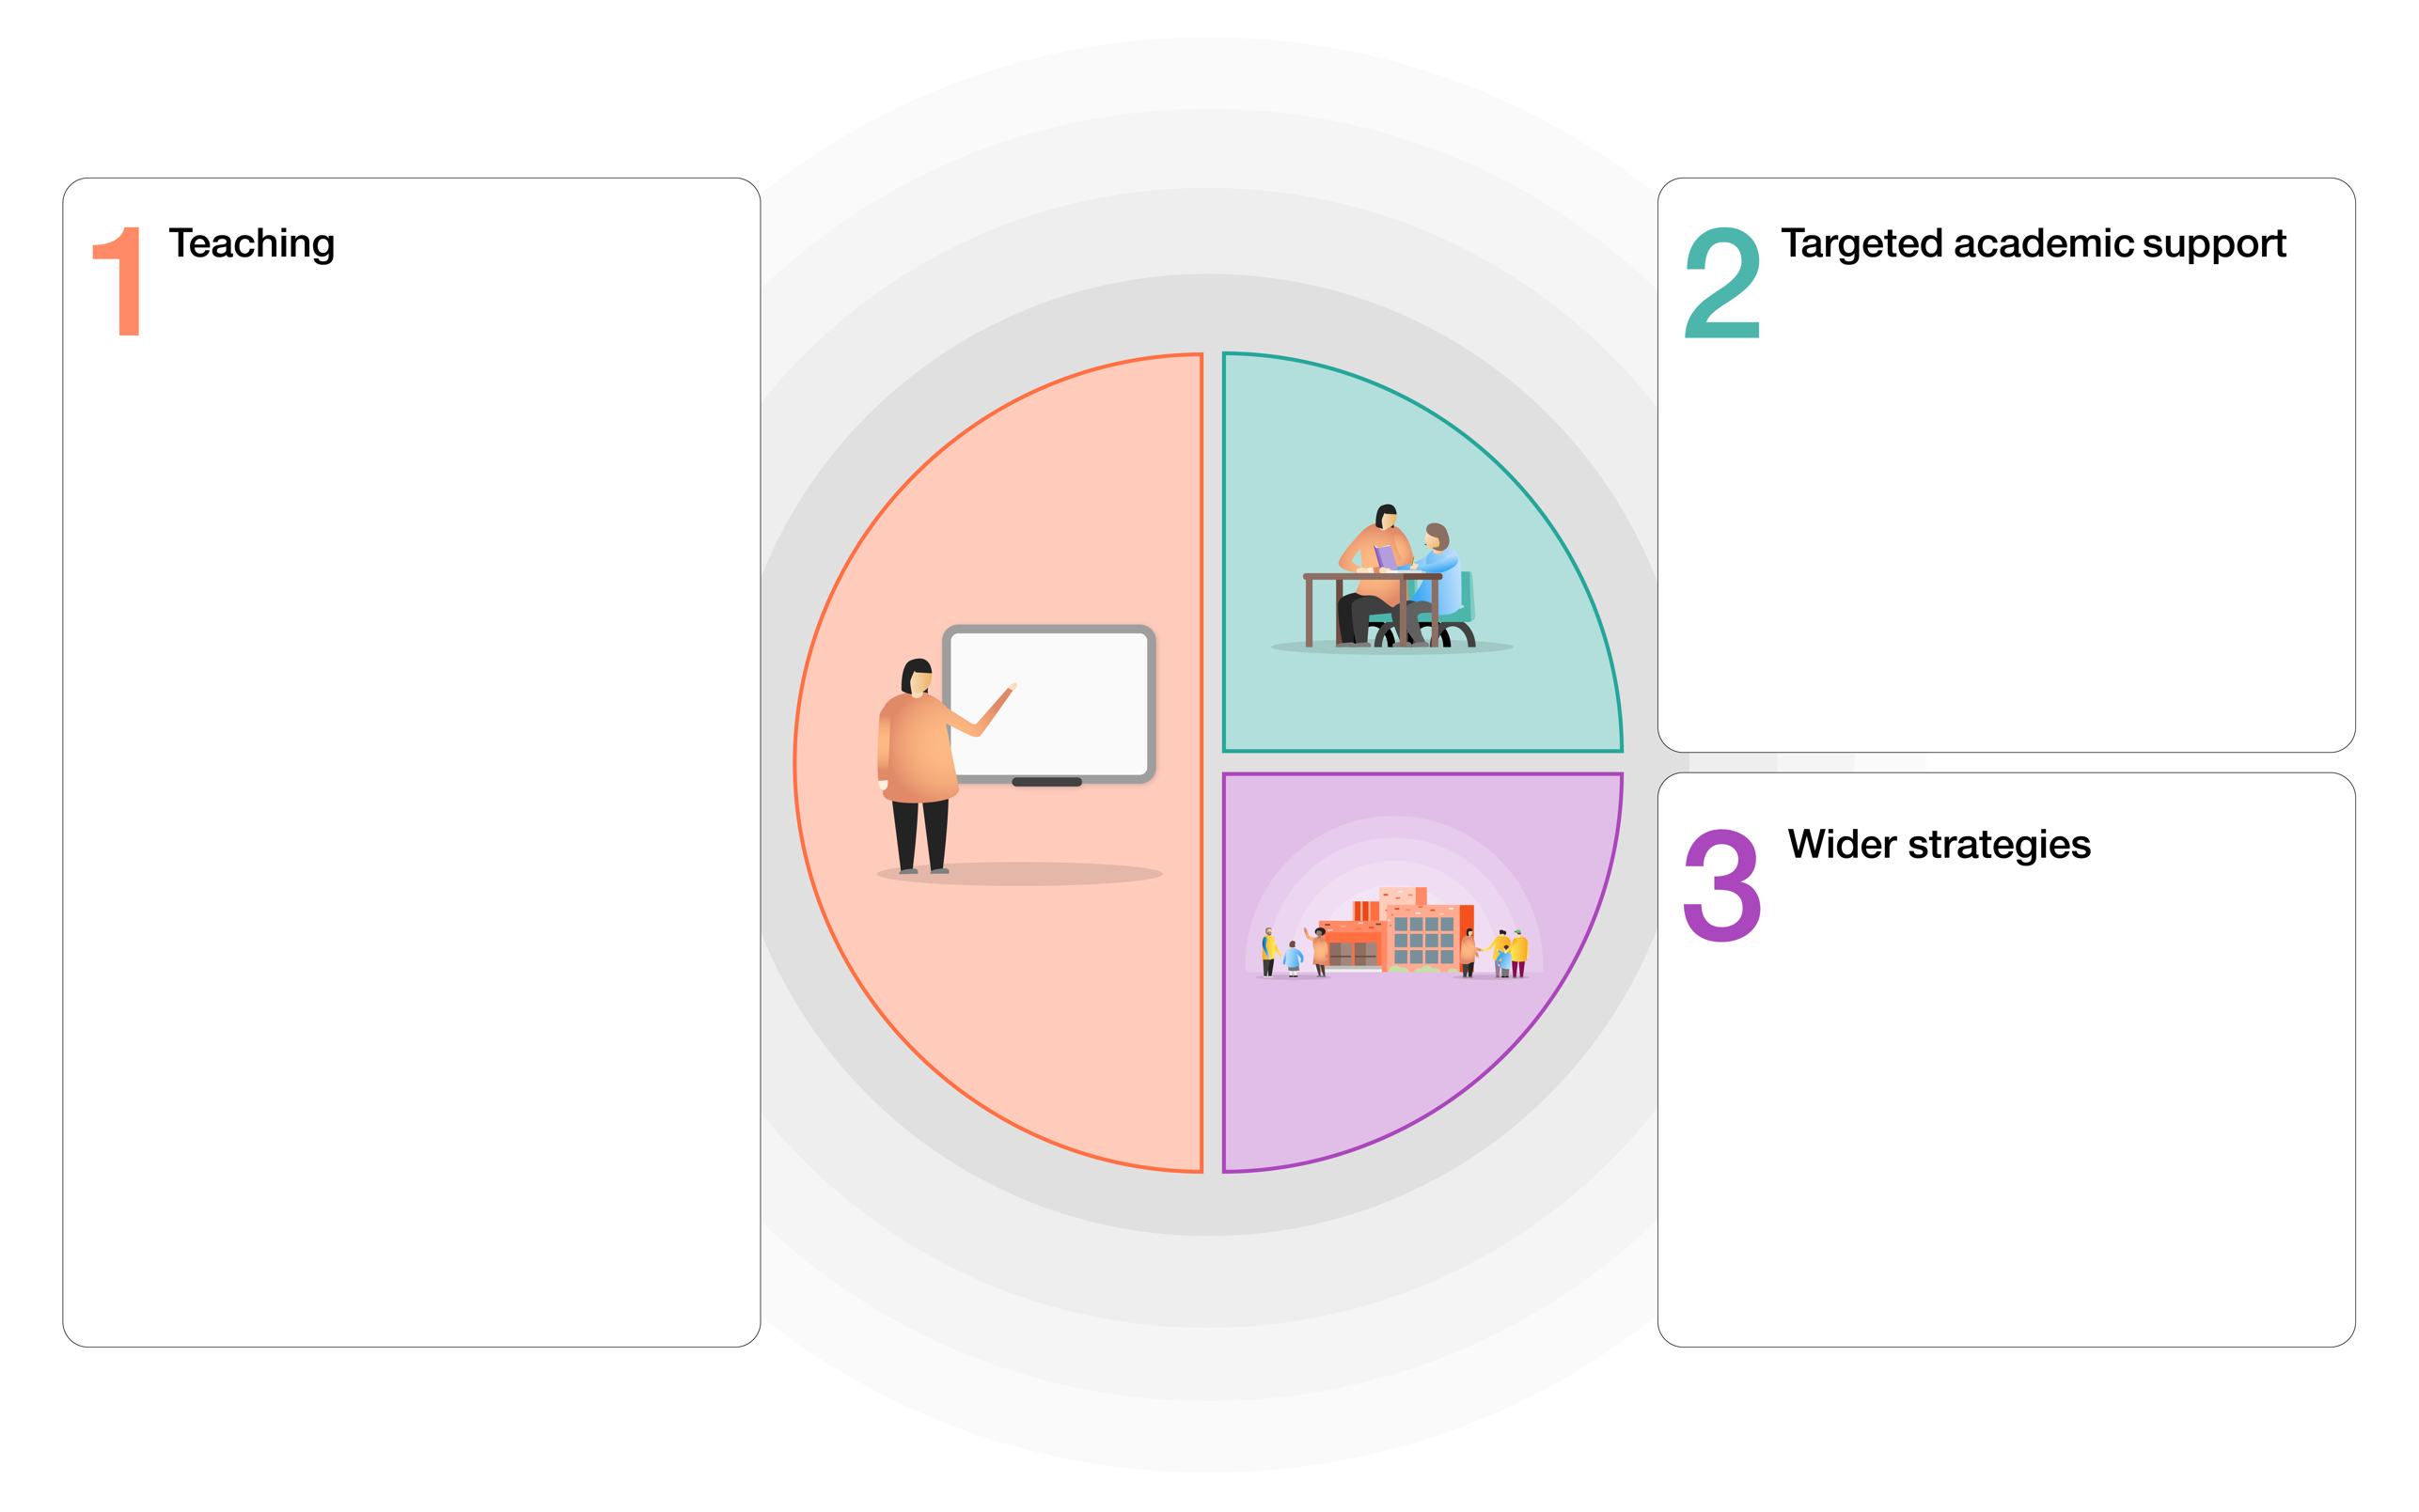
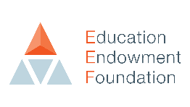
Small group phonics interventions to ensure children are secure and pass phonics test (yr1 and 2)

Focused keep up sessions to make good progress but addressing misconceptions in learning.

Early morning catch-up and pre teach opportunities for targeted children to support progress.

Speech and language catch up (NELI)

Wok with HIAS English team to develop plan and strategies to accelerate writing progress with year 5 cohort.

HIAS training – Reading fluency and stamina

Maths diagnostic tasks to unpick misconceptions and gaps in identified children

Delivering HIAS catch-up curriculum to support progress and transition from previous year group to the current.

CPD closely linked to Quality first teaching strategies and SIP target 1 (outcomes)

Develop high quality assessment strategies to identify gaps in pupils learning.

Promote Purple Mash as a remote learning tool to ensure children are provided with quality home learning opportunities.

Regular opportunities for children to read aloud to improve fluency using volunteers.

Analyse whole class and group data regularly at milestone points, analyse group and individual data in between milestone points to identify next steps.

Purchase iPads to engage learners and support opportunities for retrieval practise.

Develop library environment to promote reading for pleasure

Map out Well-being provision including at class level and beyond support.

Train ELSA to provide emotional support for vulnerable children

Training in Thrive for year 1 and PM support to complete Thrive work with identified children.
EEF GUIDE TO SUPPORTING SCHOOL PLANNING (2020-21) – TIERED MODEL
Mill Hill Primary School

