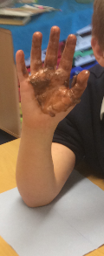
We have begun two projects in Science. One of those is our longitudinal study about space. Later this year, we have two different half-terms where we think about space: one the history of space travel in Hidden Figures and one which is about the science of space and planets. Our longitudinal study runs through the whole year and we look at how stars change. We looked at the constellations that are in the sky in September and made some predictions how these might change.
We also began our project about materials. We know that we are going to be looking at how materials change and our first experiment was about how temperature might make this change. We predicted whether we thought that butter or chocolate would melt fastest when heated by our own body temperature. Although the butter had been in the fridge, we discovered it melted a lot faster than the chocolate.
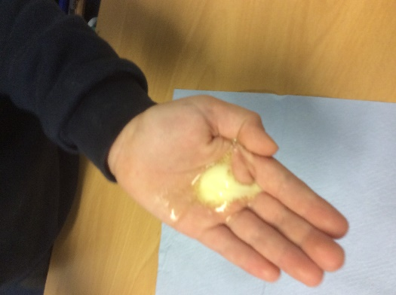
Although we know normally this would be a reversible change, we didn’t put our hands back into the fridge to reverse the change – instead we consumed the chocolate instead! This will help us later when we mix other substances and compare whether these are reversible or irreversible changes.

